Functions with Results

Look at this code:
def add_score(first, second):
total = first + second
return total
print("Score:", add_score(7, 5))

What do you think this code will display?
Click or tap here to enter text.

Run the code. Compare the result with your prediction:
Click or tap here to enter text.

Let’s investigate! Answer the questions below:
- Why is return different from print() when the caller needs to store the result?
Click or tap here to enter text.

- Why can add_score(7, 5) be used directly inside print() without first assigning the returned value to another variable?
Click or tap here to enter text.

- When add_score(7, 5) runs, which values are stored in first, second and total?
Click or tap here to enter text.

- What complete message appears when the program finishes?
Click or tap here to enter text.

Functions with Results

Look at this code:
def add_score(first, second):
total = first + second
return total
print("Score:", add_score(7, 5))

Use the code above to help you. After completing each challenge below, run your program to test that it works correctly. Save each completed challenge program in a new file.

Programming Challenges

Challenge 1
Use the same function with two different pairs of scores. Before each run, work out the total you expect, then compare it with the returned value.
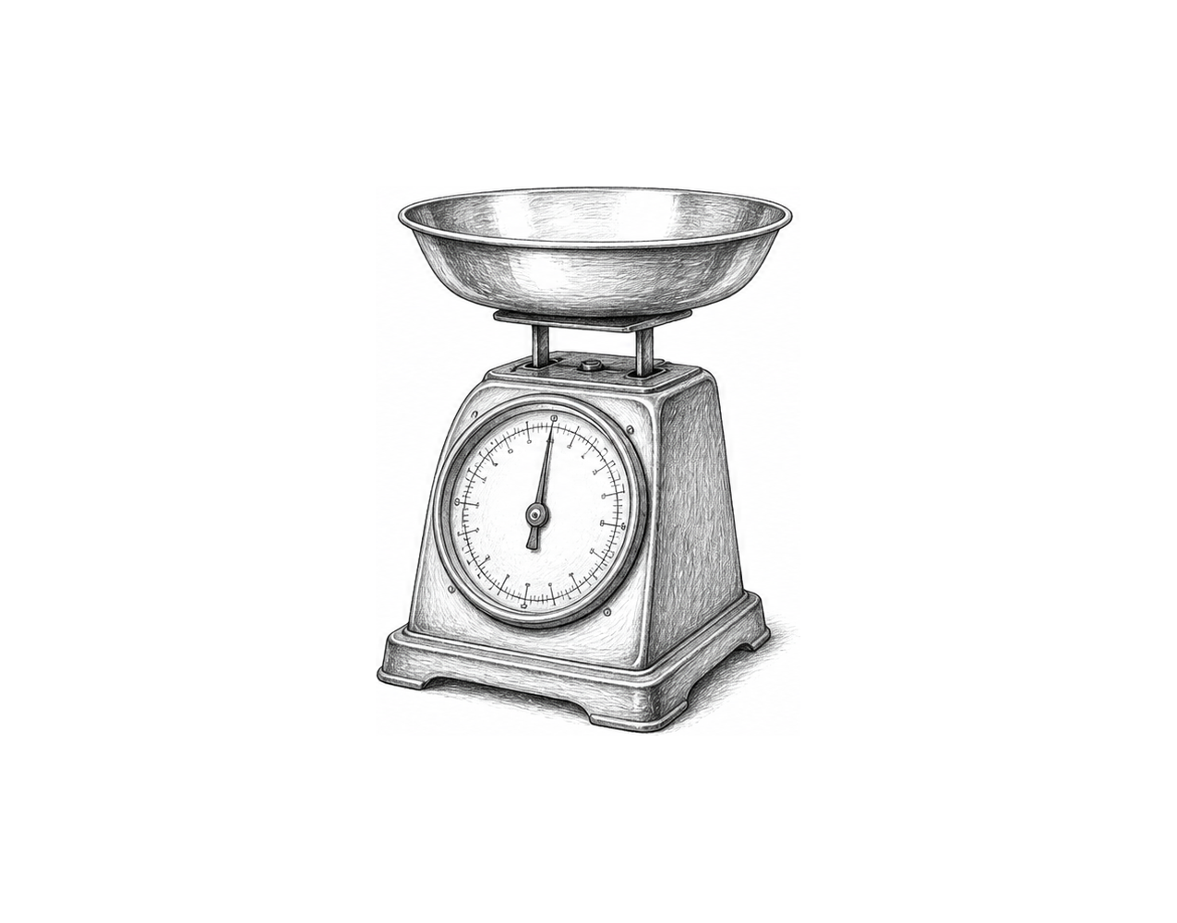

Challenge 2
Capture the returned total in a variable named score and display a labelled result on the next line. The function itself should not print the answer.

Challenge 3
A small shop needs a total_cost(price, delivery) function. Return the combined cost, store it, and display it with a clear label. For total_cost(12, 3), the result should be 15.

Functions with Results

Fix the code!

This code has errors! Look closely at the code to find the problems:

def add_score(first, second):
total = first + second
return totals
print("Score:", add_score(7, 5))

Rewrite the whole program in the box below with fixes to the errors.
Click or tap here to enter text.

After you are confident that you fixed all the errors, copy the code from the box and run it.

Did it work correctly on your first try? Did you find all the errors?
Click or tap here to enter text.

